MongoDB – Terminology

Database a container for collections

Collection – is a group of documents equivalent of a table. A collection exists within a database but no enforced schema. Documents can have different fields but typically they are related

Document – a set of key-value pairs with dynamic schema – for example, do not have the same set of fields or structure with different data types

RDBMS | MongoDB
Database | Database
Table | Collection
Row/record | Document
Column | Field
Table Join | Embedded documents
Primary Key | Primary key provided by MongoDB

MongoDB

Has no concept of relational tables

Advantages
- Variation if field & document size & data type – not fixed like SQL
- No complex joins
- Retrieves data quicker than SQL

Where would you use it?

Big Data
- Content management & delivery
- Mobile & social infrastructure

MongoDB Data Models:

Embedded data model
Normalised data model

Embedded data model
all related data is embedded in a single document – denormalised

Normalised data
Sub documents have references such as a id to the original documents

Considerations while designing Schema in MongoDB
- Design your schema according to user requirements.
- Combine objects into one document if you will use them together. Otherwise separate them (but make sure there should not be need of joins).
- Duplicate the data (but limited) because disk space is cheap as compare to compute time.
- Do joins while write, not on read.
- Optimize your schema for most frequent use cases.
- Do complex aggregation in the schema.

Example DBMS Schema

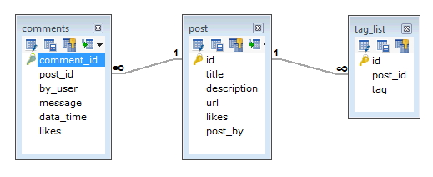
Mongo schema

{

id: POST_ID,
title: TITLE_OF_POST,
description: POST_DESCRIPTION,
posted_by: POSTED_BY,
url: URL_OF_POST,
tags: [TAG1, TAG2, TAG3 …],
likes: TOTAL_LIKES,
comments: [
{
user: ‘COMMENT_BUY,
message: TEXT,
dateCreated: DATE_TIME,
like: LIKES
},

{
user: ‘COMMENT_BUY,
message: TEXT,
dateCreated: DATE_TIME,
like: LIKES

} ]}

Mongo Document Structure

How does a collection differ from a table? Mongo stores all data in a collection. A collection hold one or more documents. Documents are analogous to rows/records in a relational database. Each document has one or more fields. Fields are similar to DBMS fields.

Collection Schema (Table)

You do not need to specify a schema for a collection in MongoDB, although it is common that documents in a collection have similar field types. - but this is not a requirement. So data types and fields can change.

Modeling relationships in MongoDB

1:1 -Use the embedded model at the bottom

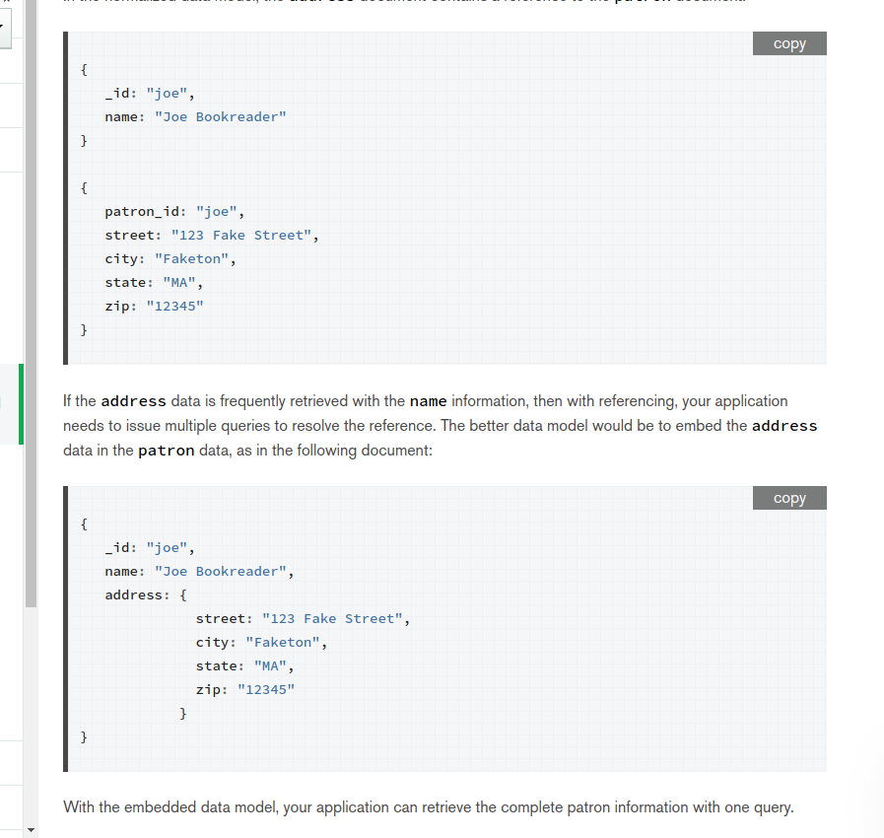

Mongo would show the data from one Collection (table) only as opposed to DBMS which would rely on three joined tables

Creating a database in Mongo

use – will create a new database if not there already

use – DATABASE_NAME

In MongoDB test is the default database. Type show dbs to show populated database

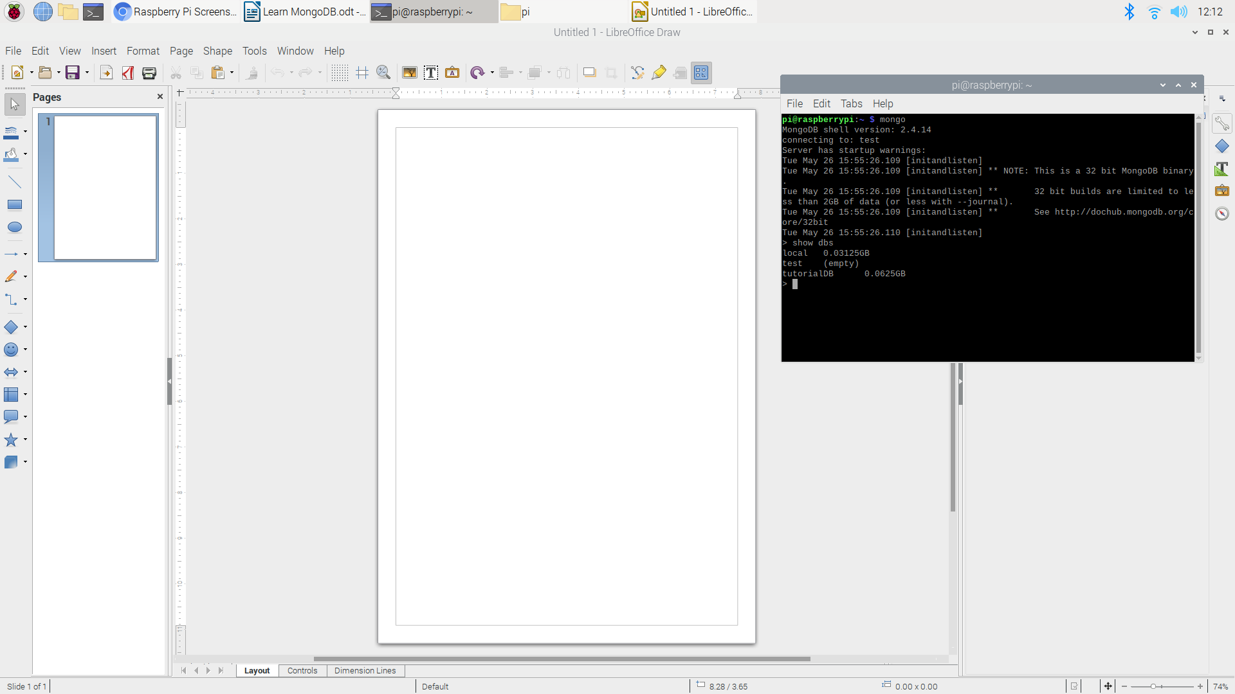

Demonstration of inserting into test dbs

db.test.insert({“name” : “mongo tutorial”})

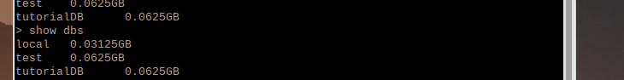

Drop Database

check for database – show dbs
select the one – use dbs
delete – db.dropDatabase()
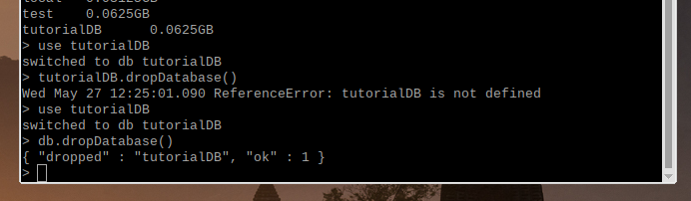

Create Collection (Table)

db.createCollection(name, options)

name – is the name of the collection
options – specifies the configuration of the collection (size and indexing)

use –database name
db.createCollection(“mycollection”) /this is a table
show collections /to see it

Drop Collection (Table)

db. <name of collection>.drop()

